Financial Statements

of the

Parochial Church Council of St Cuthbert North Wembley

For the year ending 31st December 2015

Vicar: Treasurer:
Rev Steve Morris Sarah Broadbent Book keeping
The Vicarage Janet Stern Management Accounts
214 Carlton Avenue West
North Wembley
Middx
HA0 3QY

Bankers Independent Examiner
Barclays Bank PLC Ms Catherine Nsereko
Kensington & Chelsea Group 43 Cranston Road
P0 Box 4599 Forest Hill
London SW3 1XE London SE23 2HA

2015 Report and Accounts for the Parochial Church Council of St Cuthbert’s Church North Wembley
St Cuthbert’s PCC has the responsibility of cooperating with the incumbent, the Reverend Steven Morris, in promoting the ecclesiastical parish and the whole mission of the Church.
The PCC is committed to our church growing and being a beacon of hope in this parish.
Vicar’s report – what has happened here this year, our achievements.
Hello and it has been wonderful to spend this year with you. It has been an honour to get to know you and be with you in good times and bad. It has also been good to get to understand this parish and the challenges it faces.
Like many places in our cities this is a place of many faiths and none. It is also a place where we see increasing problems of isolation and loneliness. Our heart is to be a place of hope right here and now. We have that hope because we believe that god is close and that he cares for everyone. Our mission is to love him and to love our neighbours and each other.
So this year we have started the process of reshaping the church and our mission. We have got the place open more often and looked at how to play a part here. And of course, we had Elvis (or Antony Wolfson) in the building. Just look at the dancing below.

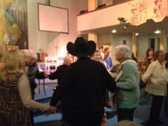

The rest of the report shows the things we are doing. But in this introduction I wanted to say how impressed I have been by the faithful band of volunteers we have here. And thank you for supporting me during an itchy Movember.
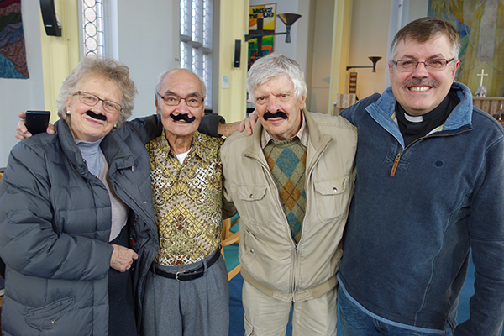

Church is voluntary. None of you need to help. But you do, and you help with joy and a servant heart. Long may it continue. Steve
Warden’s report
Our year, as a church, had begun with the ‘changing of the guard’ as the new vicar and his family settled in. Defining the word ‘CHANGE’ will give a better idea of what the church has been going through in the past year…….
CHANGE: To give a completely different form or appearance;
To transform. To cause to be different. To exchange for or replace with another. To lay aside, switch.
St. Cuthbert’s is definitely going through a transformation, the laying aside of the old and switching to the new. Steve Morris, our ‘new’ vicar, has definitely hit the ground running introducing new ways of doing church. We have graciously embraced the changes, rolled with some of the less favourable outcomes, (such as losing our children’s and youth workers) and stepped up into the voids, giving of ourselves to ensure the smooth running of the church. It has been a team effort.
OUR FINANCES
Our finances are also undergoing an overhaul with the help of our very own Bishop’s wife, Sarah Broadbent. For this we are very grateful! We have also welcomed a part time administrator, Tina Last, who is god sent. She is whipping the church office back into shape.
On another hand, grant applications for the various activities in church are beginning to come through helping us to provide services that meet genuine needs in our community.
ACTIVITIES
Summer church, last year was a success. It is a time for those who actively serve in church to take a bit of a break. We worked our way through a series of short film clips which helped reinforce the community message.
This brings me to the memory café, (one of the projects that has benefitted from the grants) set up to help and support those suffering from dementia/ Alzheimer's disease and their careers. It is a simple but brilliant way to serve our community and has opened the church to our local community in such an unusual way.
There is also the change to our monthly (previously known as all-age) service, where we now serve breakfast. This has seen growing numbers of people, especially families, attending this relaxed, simple and informal service.
Over the Christmas season, we were involved in various activities, the highlight of which was our Christmas party. This year we paid for a live band and a ‘mini’ steel band who got most of the attendees dancing, especially the children. Most importantly we had our very own Father Christmas with his trusted elf. The children loved this as each of them was given a gift and had their faces painted by Santa’s elf. There was a wide variety of food and drinks available, cooked by our members and served by our youth.

OUR BUILDINGS
In the past year, we have de-cluttered, re-arranged and refurbished some parts of the main church building. The meeting room and toilets have been through a major overhaul as well as the church office, and the entrance hall with a baby changing area installed. With a lick of paint this overhaul has given the back entrance a brand new lease of life. Some remedial electric works were also carried out to improve lighting in these areas.
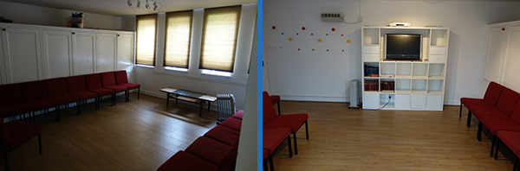
Having got a taste for these improvements, we are allowing ourselves to dream of greater possibilities for the rest of the church building, especially the church hall. More information on this will be published as the dreams become more possible in reality.
In all, the changes have been both exciting and challenging, gently pushing a lot of our members a bit out of their comfort zones. Leading to the discovery of wonderful hidden talents which range from leading worship, baking, party planning, children and youth work to gardening. All we can conclude is this, God has been good to us!
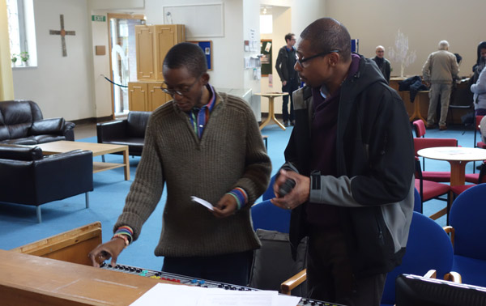

Youth
The past year has been one of upheaval for our young people. Just as they were getting used to the new vicar, their youth leader was offered a dream job elsewhere and with a heavy heart had to part ways with the St. Cuthberts’ youth. The youth have handled all these changes with a great deal of maturity. After a period of ‘mourning’, they have settled well into the changes and are in the process of planning their first youth led service in late February 2016.
We also said goodbye with great sadness to Juz. Because of the state of our finances we weren’t able to pay people to take on these roles. Although we are currently exploring some funding options. But, as ever with St Cuthbert’s, people stepped up. The church leadership is actively looking into employing a suitable youth and children’s worker who would oversee all the work with our members who are under 18years.
Opening the church and prayer
One of the real improvements this year has been that we have opened the church every morning for Morning Prayer. Lukey has led this special ministry. We have had people drop in and regular parishioners who now see mornings at church as part of their spiritual life. It is impossible to underestimate the power of this ministry. On the one hand it helps us to just be open for business, to be visible and part of this community. But prayer is so powerful and regular Morning Prayer in this place is a key element now in our spiritual life.

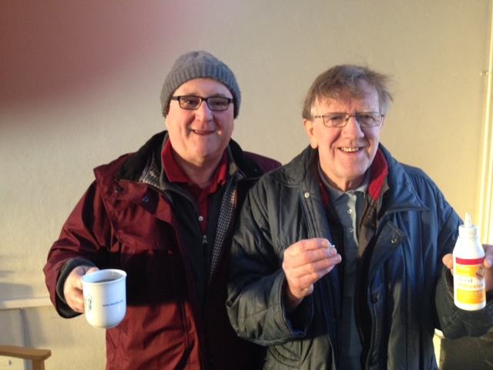

We aim to get the church open even more frequently in the year to come. And we hope to find new ways of engaging this community in prayer.
Action-packed Thursdays – the birth of the memory cafe
There is much research that points to the fact that churches grow when people get used to popping in and seeing them as normal parts of their everyday lives.
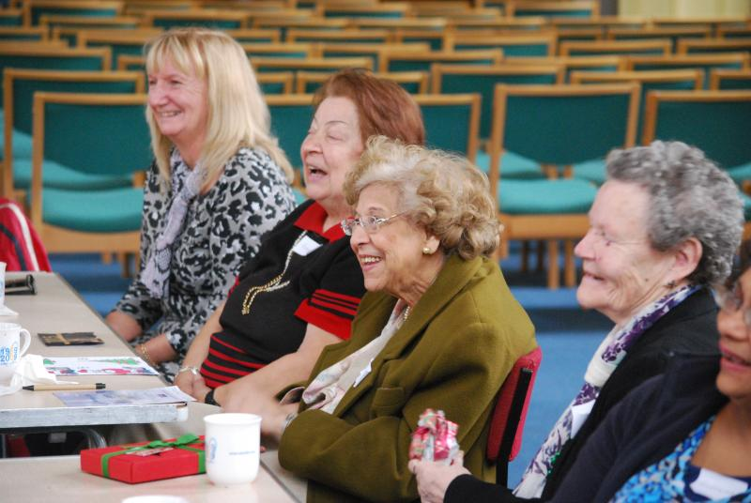
So our church is now a hub of activity each Thursday.
We begin at 9am with Morning Prayer then we hold a Communion service. This is now more informal than it was. We sit in the café area and take this as a time of Bible study and community and take the sacrament. We then move onto memory café from 11-1pm. This has proved to be a great success. We have had over 50 people coming. Our partner, The Alzheimer’s Society provides Adrian who leads the sessions beautifully and is much loved.
We have breathing exercises, memory games and fellowship and fun. People from all sections of our community come and support us. We received a grant from a charity called near neighbours to help us start the café. We hope to add a bereavement group to follow on from the café so we can impact our community with love.

Playing our part in the Diocese and the community
We have a beautiful church, with great facilities and a car park. So why not share this resource with the community and the diocese?
We have hosted many gatherings here this year. Training events from the Diocese. A fundraiser for St Luke’s. An evening on fundraising. A political husting and discussion meeting with our local MP. And to major events for St Luke’s hospice. Next year there is more to come.

Sunday services at St Cuthbert’s welcome to café church
We have made some changes to help make our Sunday’s more accessible.
We moved our traditional 9am service to 9.30am. This allowed us to have a time of fellowship between both Sunday services. Our aim was to help us to feel like family. On the first Sunday of the Month we now have just have one service – Café Church.
We have a film clip, a sumptuous breakfast and newspapers. All are welcome and this is very much an out-reach service. The whole style is relaxed, with time for discussion and reflection. We have found the attendance at café church outstrips regular Sundays. Our 11am service remains informal and Charismatic in nature – although a bit shorter than it was. Our aim is to offer a real mix of services – some traditional (Remembrance Sunday, memorial service) some Contemporary. We have encouraged new preaching talent from within the congregation

Worship
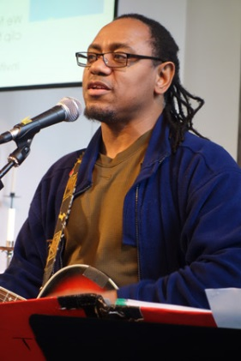
We have a great musical heritage here. We now have a few different worship leaders and band formats. Plus Paul Stanley does sterling work on the organ.
We want to bring on musical talent here and introduce new songs in the year to come.
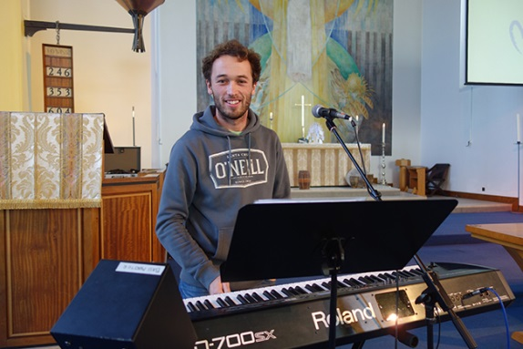
Safeguarding
This has been a year of change and development with Juz's departure and the start of new outreach initiatives. Before she left, Juz and Hazel reviewed St Cuthbert's safer recruitment procedures especially with regard to those working with children and youth. Where necessary, these will now extend to those working with vulnerable adults.

D.B.S checking continues for new workers and for those whose CRB checks were more than five years ago. Hazel has received training from the Diocese of London in both DBS evidence checking and Safeguarding

Volunteers
With numbers down our volunteers have been stretched.
The appointment of our vergers – Avril and Paul has been a great help. But so many people get involved – on sound and vision, on tea and coffee and generally doing all the things a church needs.
Deanery Synod and electoral roll
Hazel Bathurst is our Deanery Synod Rep. We have 108 on our electoral roll. Of these 56 lived outside the parish; 10 people came off the register, all of whom had either died or moved away; 9 people were added.
Community Payback
Our Community Payback team now join us at café church.
The Community Payback team started with us in the spring of 2014 and came at a time when the church grounds needed more care and attention than we could provide.
The main work done last year was to remove large amounts of weeds and rubble from the area by the side of the church. Then levelling the ground, prior to the laying of turf, sowing of grass seed, and helping to water the grass in a dry period until it became established.
Trees lining the path that runs parallel with the church were cut back to keep the path accessible. Weeds were removed from the main beds and nettles cut back in other areas. Roses and other flowers were planted but more are still required. The mature trees in the grounds produced many fallen leaves and in the autumn a lot of time was spent removing them.
Just as we benefit from the work that is done for us ,the people in the Community Payback team also benefit. Some of them do not have their own gardens and this is their first gardening experience. Also they come from many different countries and during their time with us learn to work together as a team.
Tea @3
Tea at Three meets on the 3rd Wednesday of each month at Lynn’s house in Pasture Road. Our current numbers run at about 12 or less and consist largely of a group of St Cuthbert’s people over the age of 50 upwards who meet to catch up, deepen our friendship and enjoy each other’s company for a couple of hours each month.
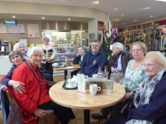
We start with a cuppa and a prayer to bless our meeting and have a general welcoming chat. We then read a short passage from the bible and we pick out the theme and move on to a few discussions based on the passage relating it to our own lives. We follow this with a game, a craft or an exercise connected as far as possible to the Biblical theme.
Halfway through we break for tea – sandwiches and cakes, during which we have a general knowledge quiz which we try to make educational as well as fun. We welcome anyone who wants a little company and to share a cuppa in a loving spiritual atmosphere, even for one session as a trial, do come and join us! We can offer lifts to anyone who struggles with mobility.
Ploughman’s
We hold these lunches from 12 noon on the first Monday of the month, enjoying rolls and cheeses, salad and cake and coffee or tea. This year we met on 8 occasions.
There were sad times and happy times this year. Our dear friend Derek Smith, who for many years had helped with the preparations for the lunches, died in March and is sadly missed. Valerie is helped by David Loder, along with Ruth Bray, our faithful supporter.
One happy occasion, for Valerie, was a surprise celebration of her special Birthday, for which Ruth provided a wonderful cake and balloons! Thank you, Ruth! We have always welcomed our vicar at these lunches and were delighted when Rev Steve Morris joined us in March just before his induction to St Cuthbert's. It was lovely to get to know him and we are pleased that he has continued to come when possible.
We always have plenty of friendly chat and lots of laughter, as well as having a chance to discuss topics of interest in our Church life. We have a regular group of about 10 or 11 and would welcome anyone who is available to join us. Just turn up
Financial report
At a glance – general fund
 | 2015 | 2014
Deficit (loss) for the year on day-to-day costs | (£5,664) | (£3,684)
Income from giving down by £8,304 | £69,342 | £77,646
Additional one-off donations brought in – designated funds at vicar’s discretion | £28,413 | £0
Hall income being maximised but benefits not fully felt yet, as accounts show | £19,533 | £23,826
Diocesan quota maintained, but we are still paying £20,000 less than we should | £46,500 | £46,500
No mission spending this year | £0 | £21,434
Balance at year end in deposit account | £42,583

Other funds
No legacy money received in 2015. Additional one-off donations to be used at the vicar’s discretion: £28,413.

Reserves policy
As a PCC, we have not previously had a reserves policy. We have considered the need to start a reserves policy, and agreed that we will hold our reserves in the deposit account. This is to provide primarily for the capital liabilities to come with the electrics (see below). Our first priority is to reach our target of £60,000. We will keep this reserves total under review with the PCC and develop a more detailed policy as we move forward. It may be as the amount accumulates that we can find a place with a greater return, and we will take advice on this. However, at the moment, there are no reserves to manage.

Liabilities on the horizon
Electrics in 2017. Estimated at £60,000 to do the necessary renewal of the electrics. Our current electrics are not unsafe, but the advice from our architect is that we will need to replace them by 2017.
Additional activities this year
Memory café. (received grants to cover costs)
Café church. Running costs of an additional £50 a session, but this counts as our mission outreach.
Church open most mornings for morning prayer. People are starting to drop in.
Hosted events for the Diocese and other bodies to bring people to our church.
Some remedial electrical work done, and improvements to the fabric of our church (meeting room, toilets, hall, fences, lawn)

What is the story behind the numbers?
At first glance this is a gloomy picture, but it isn’t the full story.
- We have managed to increase our activity and presence in the community, moving us closer to becoming a parish church at the heart of our community. We introduced two new services – the Memorial Service and Café church. We have a weekly outreach event in Memory café.
- We have been chosen by the Diocese, Brent Council and St Luke’s to host events. This raises our profile with our church and local communities.
- We have undertaken works to improve our safety and appearance. Completed works include: urgent works on the electrics, toilets, meeting room, hall, painted the church door, fences, removed dangerous walls, laid a new lawn.

Increasing our activities, without substantially burdening our finances, at a time when income is falling is a remarkable achievement. It shows good stewardship and our commitment to continue to spread the Gospel and be a blessing to our community.

Changing the trend
However, our falling income from giving is a problem – and especially so when we consider the liability of £60,000 on the horizon for the electrics. This isn’t an option for us: if we do not raise the money to renew our electrics, the church will have to close on safety grounds.

We are examining our costs critically to reduce our outgoings. Our biggest single cost is heating and we are tied into long term contracts at a high rate with British Gas until 2017. We have exited one, saving £1,000, but still cannot get out of two contracts.

We are maximising income by improving the hourly letting rates. We have now given notice on the Nursery, and will re-negotiate the contract there at a more commercial rate. We are also applying for grants and did successfully attract funding for the Memory Café. However, funders tend not to fund on-going costs: they want to see new projects to justify the expenditure, so this is not a solution to our cashflow problem.

As a church, we have some simple, stark options:
- we need to give more on Sunday
- we need to fundraise
- we need to consider legacies
- we need to start a special set-aside fund for our electrical repairs/renewal.

Of course, increasing our congregation is one way of increasing our income, and we hope that our outreach events at Café church and Memory café will bear fruit. But we cannot rely on this.

It is our responsibility as a church family to pay our own way. We have a duty to pass the church on to the next generation. We also have a duty to keep it open, warm and relevant so that we can continue to extend the hospitality of Christ to those beyond our doors.

What you can do
We have a clear vision as a church that we want to be a blessing to our community. Let’s make it more than just fine words. So please pray for our finances and for God’s guidance on your role.

Can you:
- give more?
- give from your estate and add a legacy into your will?
- commit to pray more?
- give time to fundraise?

Especial thanks
To those who have helped us to keep or accounts in order, and produce these figures: Ann Murdoch for sterling service over the years, Janet Stern who makes time in a busy accountant’s life to help us each year, Sarah Broadbent who has generously stepped in to keep our books beautifully.

Structure, governance and management
The methods of appointment of PCC members is set out in the Church Representation Rules. At St Cuthberts, the membership of the PCC consists of the incumbent, churchwardens, and members elected by the members of the congregation who are on the electoral roll of the church.

The PCC members are responsible for making decisions on all matters of general concern and importance to the parish including on deciding how the funds of the PCC are to be spent.

The PCC met six times during the year with an average attendance of 75%. We have no sub committees.

Administrative information
St Cuthberts church is at 214 Carlton Avenue West, North Wembley, Middlesex, HA0 3QY. It is part of the Diocese of London, in the Willesden area. The PCC is a body corporate (PCC Powers Measures 1956, Church Representation Rules 2006) and a charity currently excepted from registration with the Charity Commission.

PCC members who have served at any time from 1st January 2015 until the date this report was approved are:

Names of the PCC members
Ex Officio members
The Reverend Steve Morris
Dotun Adebayo (churchwarden)
Tyrone De Silva (churchwarden)

Elected members
Hazel Bathurst (representative on the Deanery Synod)
Lynn Dube
Mike Atakpu
Avril Nickolson
Patrick Alleyne
David Loder
Neil Brookwick
Maggie Johnson
Martina Murphy
Jennifer Lee
Christine Morris (treasurer)

Approved by the PCC on 7 March 2016 and signed on their behalf by the Reverend Steve Morris.

Independent Examiner’s Report to the PCC of St Cuthbert’s PCC, North Wembley
I report on the accounts of the PCC for the year ended 31 December 2015, which are set out on pages 18 to 22.
Respective responsibilities of trustees and examiner
As members of the PCC, you are responsible for the preparation of the accounts. You consider that an audit is not required for this year under Regulation 3(3) of the Church Accounting Regulations 1997 to 2001 (the Regulations) and section 144(2) of the Charities Act 2011 (the 2011 Act).
Having satisfied myself that the charity is not subject to audit and is eligible for independent examination, it is my responsibility to:
- Examine the accounts under section 145 of the 2011 Act and Regulation 3(3);
- To follow the procedures laid down in the general Directions given by the Charity Commission under section 145(5)(b) of the 2011 Act; and
- To state whether particular matters have come to my attention.

Basis of independent examiner's report
My examination was carried out in accordance with the general Directions given by the Charity Commission and guidelines from the Finance Division of the Archbishop’s Council. An examination includes a review of the accounting records kept by the PCC and a comparison of the accounts presented with those records. It also includes consideration of any unusual items or disclosures in the accounts, and seeking explanations from you as trustees concerning any such matters. The procedures undertaken do not provide all the evidence that would be required in an audit and consequently no opinion is given as to whether the accounts present a 'true and fair view' and the report is limited to those matters set out in the statement below.
Independent examiner's statement
In connection with my examination, no matter has come to my attention:
- Which gives me reasonable cause to believe that in any material respect the requirements to:
- Keep accounting records in accordance with section 130 of the 2011 Act; and
- To prepare accounts which accord with the accounting records, comply with the accounting requirements of the 2011 Act, the Regulations and with the methods and principles of the Statement of Recommended Practice: Accounting and Reporting by Charities have not been met; or
- To which, in my opinion, attention should be drawn in order to enable a proper understanding of the accounts to be reached.

Catherine Nsereko
43 Cranston Road, Forest Hill, London SE23 2HA
12 March 2016
Parochial Church Council of St Cuthbert, North Wembley
Notes to the Financial Statements – for the year ended 31December 2015

Accounting Policies
The financial statements of the PCC have been prepared in accordance with the Church Accounting Regulations 1997 as amended by the Church Accounting (Amendment) Regulations 2001 together with applicable accounting standards and the Charities SORP. The financial statements have been prepared under the historical cost convention.

Funds
General Fund represents the funds of the PCC that are not subject to any restrictions regarding their use and are available on the general purposes of the PCC. Funds designated for a particular purpose by the PCC are also unrestricted.
The accounts include transactions, assets and liabilities for which the PCC is responsible in law. They do not include the accounts of other church groups that owe an affiliation to another body, nor those that are informal gatherings of Church members.

Incoming Resources

Voluntary income and capital sources
- Collections are recognised when received by or on behalf of the PCC.
- Planned giving receivable under Gift Aid is recognised only when received.
- Income tax recoverable on Gift Aid donations is recognised when the income is recognised.
- Grants and legacies to the PCC are accounted for as soon as the PCC is notified of its legal entitlement, the amount due is quantifiable and its ultimate receipt by the PCC is reasonably certain.
- Funds raised at fund raising events are accounted for gross.
- Sales of books and magazines from the bookstall are accounted for gross.

Other Income
Rental income from the letting of church premises is recognised when the rental is due.

Income from Investments
Interest entitlements are accounted for as they accrue.

Gains and losses on investments
Realised gains and losses are recognised when investments are sold.
Unrealised gains and losses are accounted for on revaluation of investments at 31 December.

Resources Used
Grants
Grants and donations are accounted for when paid over or when awarded if that award creates a binding obligation on the PCC

Parochial Church Council of St Cuthbert, North Wembley
Notes to the Financial Statements – for the year ended 31December 2015

Activities directly relating to the work of the church
The diocesan parish share is accounted for when paid. Any parish share unpaid at 31 December is provided for in these accounts as an operational (though not legal) liability and is shown as a creditor in the balance sheet.

Fixed Assets
Consecrated property and moveable church furnishings:
Consecrated and beneficed property of any kind is excluded from the accounts by S.10(2)(a) & ( c) of the Charities Act 2011.
Movable church furnishings held by the Vicar and Churchwardens are on special trust for the PCC and which require a faculty for disposal are accounted as inalienable property unless consecrated. They are listed in the church’s inventory which can be inspected (at any reasonable time). For unalienable property acquired prior to 2004 there is insufficient cost information available and therefore such assets are not valued in the accounts. Items acquired since 1 January 2004 have been capitalised and depreciated over their current anticipated economic life (initially 4 years) on a straight line basis.
All expenditure incurred on the year on consecrated or beneficed buildings, individual items under £1500 or on the repair of moveable church furnishings acquired before 1 January 2005 is written off.

Other fixtures , fittings and office equipment
Equipment used within the church premises is depreciated on a straight line basis over 4 years. Individual items of equipment with a purchase price of £1500 or less is written off when the asset is acquired.

Other Functional Assets
Land and buildings held on behalf of the PCC for its own purposes (with LDF acting as Custodian Trustee) is included at estimated market value. In the case of the Church Hall this is valued at £744,063 ( insurance value).

Investments
Investments are valued at market value at 31 December.

Current Assets
Amounts owing to the PCC at 31 December in respect of fees, rents and other income are shown as debtors less provision for amounts that may prove uncollectible.

Rounding
Where minor variances occur due to rounding adjustment – caused by accounting in two decimal places but reporting to nearest pound –these variances have been ignored and not corrected in these accounts.

