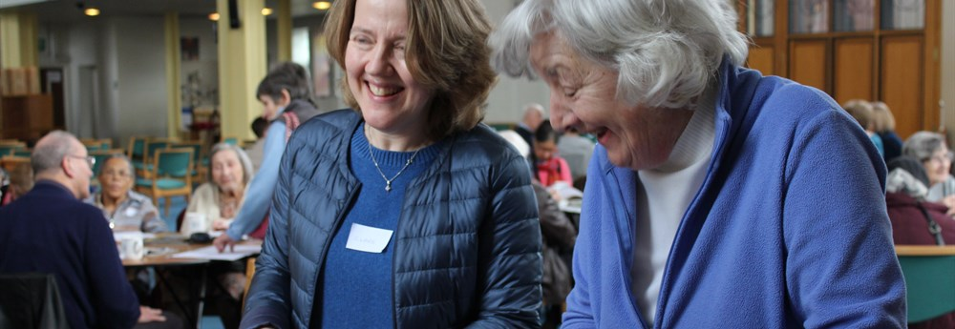

REMEMBERING TOGETHER
Friendships which stretch cross faiths and cultural backgrounds are forming in North Wembley thanks to the welcome of St Cuthbert’s church there, which hosts a weekly ‘Memory Café’.
The café, which takes place inside the church and provides light refreshments, a quiz, exercise, singing and plenty of opportunity for conversation, aims to reach those who are isolated, lonely, or just looking for a way to find new friends and help others in the community. It benefited from a £5,000 Near Neighbours grant, which helps to pay for the necessary publicity materials and heating the huge church.
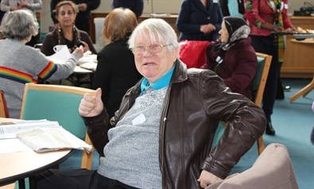
“Despite the name, we’re not really a dementia café,” says the vicar Steve Morris, who’s keen to extend a welcome to anyone in the local area who would like to come along, “but there are some people with dementia who come here with their carers. We have the support of an Alzheimer’s Society representative, so that we can be dementia-aware, which I think is really important, but there are many people who come here who are simply looking for companionship.”
Steve explained how the local community has no nearby shops, pubs or public spaces. As a consequence, people who live on their own, or are caring for someone at home, can become isolated, lonely and even depressed. In reaching those people, Steve believes the café could be a lifesaver.
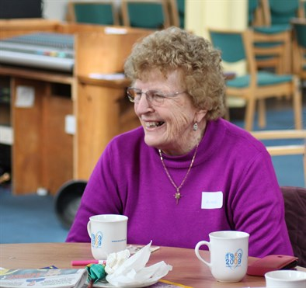
“Of course these are the sorts of experiences that are not confined to one faith or culture,” said Steve. “People can be lonely, suffer with memory problems or be caring for someone regardless of their nationality. Many nationalities and faiths are represented here and organisations with routes in other cultures support us too. We hope the Punjabi Association will come and visit to do some bhangra dancing for us, and the local Indian restaurant donates food sometimes.”
Steve confessed that when the Memory Café was first set up at the end of 2015 they were very low on funds, but with the kettle, some biscuits and a quiz, they were able to welcome nine local people from day one. In less than two years and with the help of the Near Neighbours grant, it has grown to around 60 participants each week, for no less than 51 weeks a year. There are participants who are Jewish, Sikh, Hindu, Christian and of no faith.
Memory Café participant Rosemary, who is Malta-born, is a former lecturer at the University of Westminster. She explained how low she felt after retirement and was also a widow of 18 years.
She said: “I was so used to being surrounded by people in my work, so not speaking to anyone for weeks on end was just not what I was used to. I became very lonely. I came along to one of the Memory Café sessions and found that Steve was so genuine, warm and welcoming. He treats everyone like family – he’s like a magnet! And then I found I was able to make friends with people in my own neighbourhood and even met someone living here who went to my old school. We shared so many memories about those days and it is a joy to me to have found a connection like that, right here. It seems so unlikely, but you can’t discover those things in common until you talk to people.”
A volunteer at the café, Eleanor, said: “This is so brilliant for the community. There are English, Asian, West Indian, African and European people here and we are all one family. We talk, sing and laugh together. For me, it is something positive I can do, just by being here.”
Steve added: “It was quite a leap of faith to set this up if I’m honest, and we couldn’t have done what we’re doing now without the Near Neighbours grant. We just want to be a place of blessing and hospitality and it’s truly amazing how important that can be for people. It’s the best thing I’ve ever done. My deepest hope is that other churches, libraries, prisons, shelters and charities can see how easily it can be done and try it for themselves. I believe there is a great need for this in many communities, so if it were to become a national movement, that would indeed be an answer to prayer.”

