saintcuthberts
north wembley

Eucharist
in Ordinary Time

-Greeting-

In the name of the Father, and of the Son, and of the Holy Spirit. Amen.

The Lord be with you
and also with you.

Informal confession

-Prayers of Penitence-

May almighty God have mercy on us, forgive us our sins, and bring us to everlasting life. Amen.

-The Gloria-

Glory to God in the highest, and peace to his people on earth.

Lord God, heavenly King,
almighty God and Father,
we worship you,
we give you thanks,
we praise you for your glory.

Lord Jesus Christ, only Son of the Father,
Lord God, Lamb of God,
you take away the sin of the world:
have mercy on us;
you are seated at the right hand of the Father:
receive our prayer.
For you alone are the Holy One,
you alone are the Lord,
you alone are the Most High, Jesus Christ,
with the Holy Spirit,
In the glory of God the Father. Amen.

-The Collect-

Let us pray:
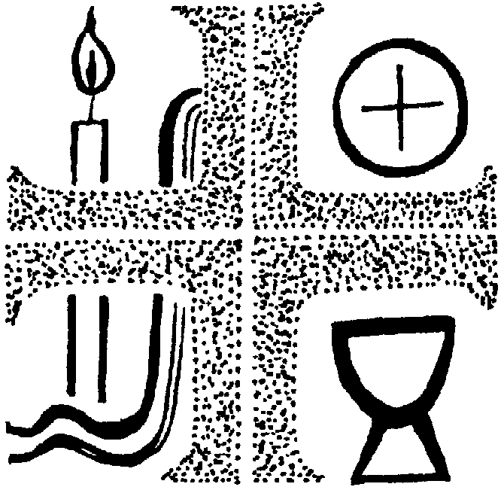

THE LITURGY OF THE WORD

-Reading-

-Sermon-

-The Creed-

We believe in one God,
the Father, the Almighty,
maker of heaven and earth,
of all that is, seen and unseen.
We believe in one Lord, Jesus Christ, the only Son of God,
eternally begotten of the Father, God from God, Light from Light,
true God from true God,
begotten, not made,
of one Being with the Father; through him all things were made.
For us and for our salvation he came down from heaven, was incarnate from the Holy Spirit and the Virgin Mary and was made man.
For our sake he was crucified under Pontius Pilate; he suffered death and was buried.
On the third day he rose again in accordance with the Scriptures;
he ascended into heaven
and is seated at the right hand of the Father.
He will come again in glory to judge the living and the dead, and his kingdom will have no end.
We believe in the Holy Spirit, the Lord, the giver of life, who proceeds from the Father and the Son,
who with the Father and the Son is worshipped and glorified, who has spoken through the prophets.
We believe in one holy catholic and apostolic Church.
We acknowledge one baptism for the forgiveness of sins.
We look for the resurrection of the dead, and the life of the world to come. Amen.

-Prayers of Intercession-

This response:
Lord, in your mercy
Hear our prayer

And at the end:

Merciful Father,
accept these prayers
for the sake of your Son,
our Saviour Jesus Christ. Amen.

THE LITURGY OF THE SACRAMENT

-The Peace-

The peace of the Lord be always with you
and also with you.
Let us offer one another a sign of peace.

Exchange a sign of peace with someone in your household or name a family member or friend.

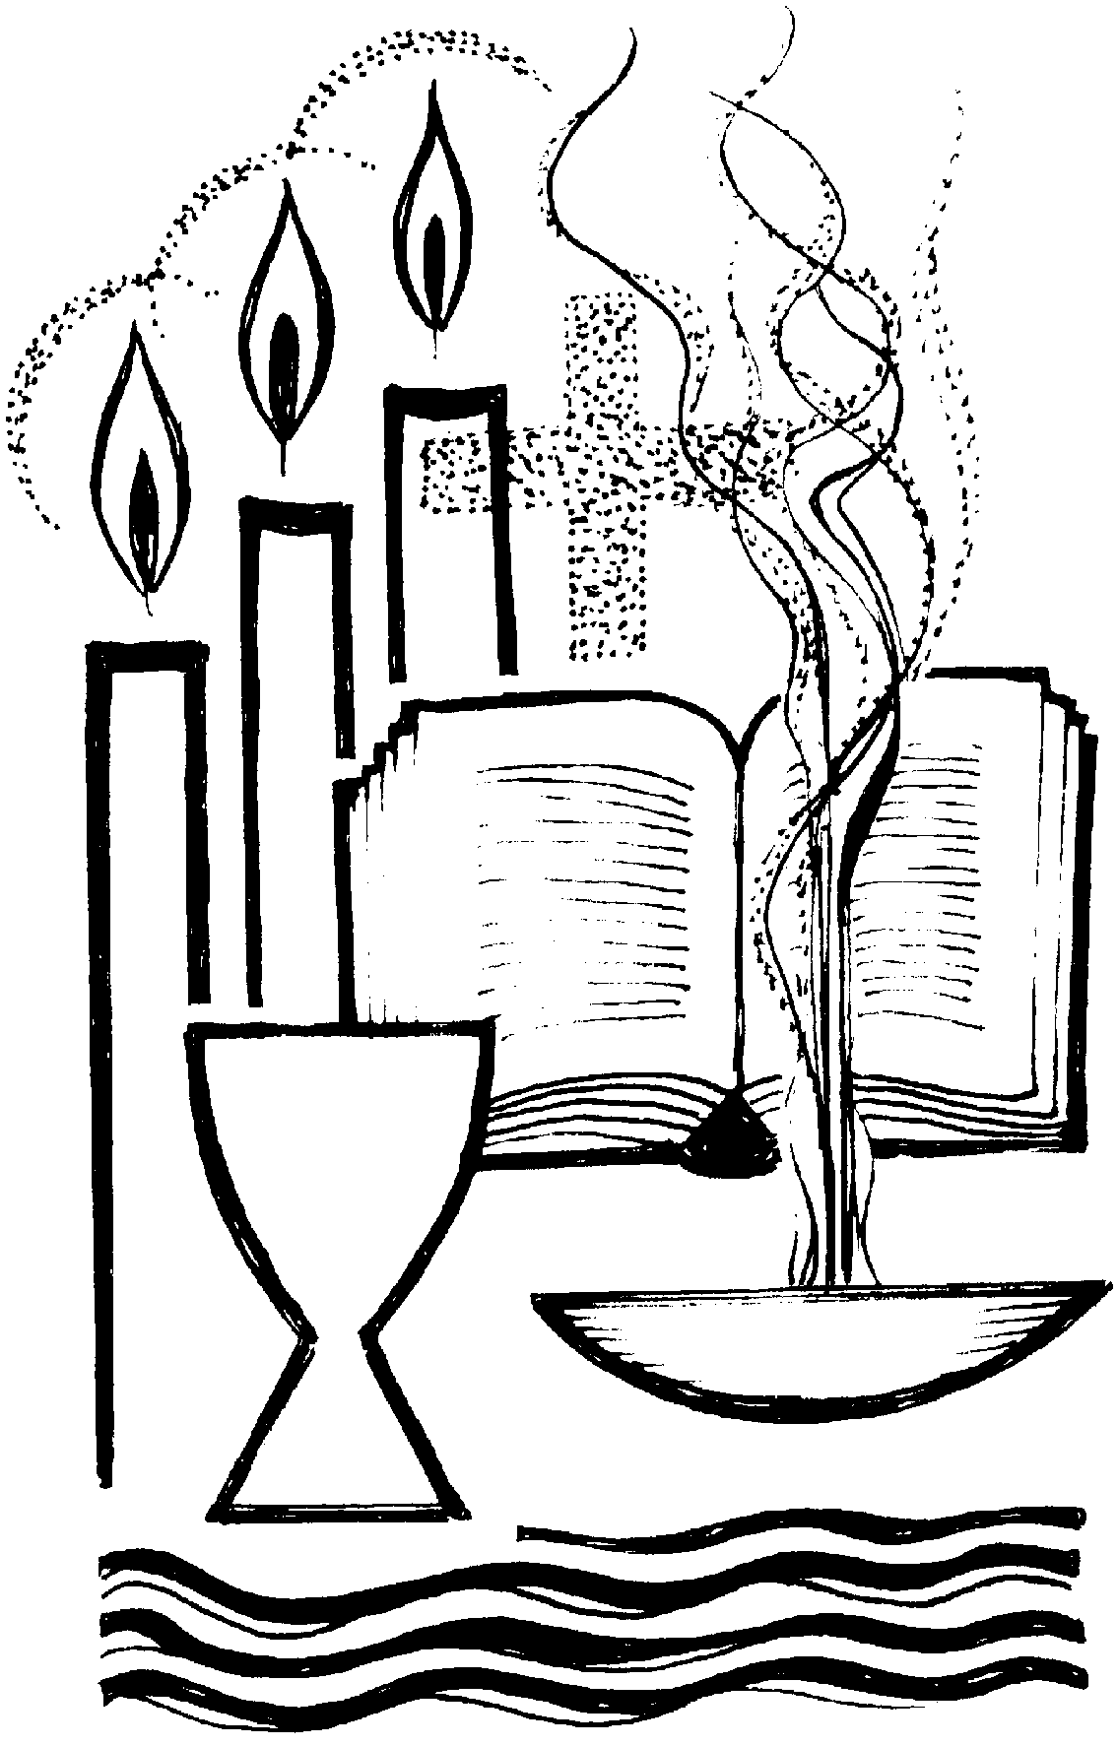

.
The Eucharistic Prayer-

The Lord be with you
and also with you.
Lift up your hearts.
We lift them to the Lord.
Let us give thanks to the Lord our God.
It is right to give thanks and praise.

Father, you made the world and love your creation.
You gave your Son Jesus Christ to be our Saviour.
His dying and rising have set us free from sin and death.
And so, we gladly thank you,
with saints and angels praising you, and saying:

Holy, holy, holy Lord,
God of power and might,
heaven and earth are full of your glory.
Hosanna in the highest.
Blessed is he who comes in the name of the Lord.
Hosanna in the highest.
We praise and bless you, loving Father, through Jesus Christ, our risen Lord; and as we obey his command, send your Holy Spirit, that broken bread and wine outpoured may be for us the body and blood of your dear Son.
On the night before he died, he had supper with his friends and, taking bread, he praised you. He broke the bread, gave it to them and said: Take, eat; this is my body which is given for you; do this in remembrance of me. When supper was ended, he took the cup of wine. Again, he praised you, gave it to them and said: Drink this, all of you; this is my blood of the new covenant, which is shed for you and for many for the forgiveness of sins.
Do this, as often as you drink it, in remembrance of me.
So, Father, we remember all that Jesus did, in him we plead with confidence his sacrifice made once for all upon the cross.
Bringing before you the bread of life and cup of salvation,
we proclaim his death and resurrection until he comes in glory.

Great is the mystery of faith

Christ has died:
Christ is risen:
Christ will come again.

Lord of all life, help us to work together for that day
when your kingdom comes
and justice and mercy will be seen in all the earth.
Look with favour on your people, gather us in your loving arms and bring us with all the saints to feast at your table in heaven.
Through Christ, and with Christ, and in Christ,
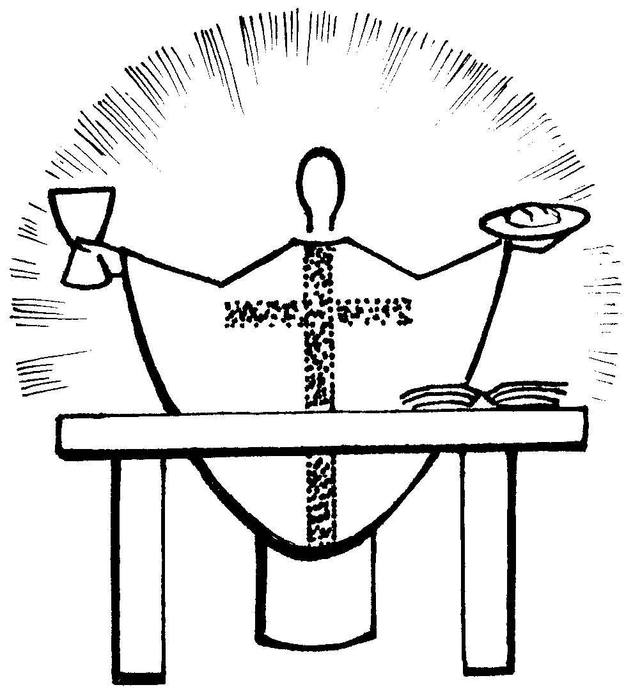

in the unity of the Holy Spirit, all honour and glory are yours, O loving Father, for ever and ever. Amen.

-The Lord’s Prayer-

Our Father in heaven,
hallowed be your name,
your kingdom come,
Your will be done,
on earth as in heaven.
Give us today our daily bread.
Forgive us our sins as we forgive those who sin against us.
Lead us not into temptation
but deliver us from evil.
For the kingdom, the power, and the glory are yours now and forever. Amen.

-Breaking of the Bread-

We break this bread to share in the body of Christ.
Though we are many, we are one body, because we all share in one bread.

Prayer after Communion-

Almighty God,
we thank you for feeding us with the body and blood of your Son Jesus Christ.
Through him we offer you our souls and bodies to be a living sacrifice.
Send us out in the power of your Spirit to live and work to your praise and glory. Amen.

-The Dismissal-

Informal blessing
Amen.
Go in peace to love and serve the Lord.
In the name of Christ. Amen.

