saintcuthberts
north wembley

Lent Eucharist Service
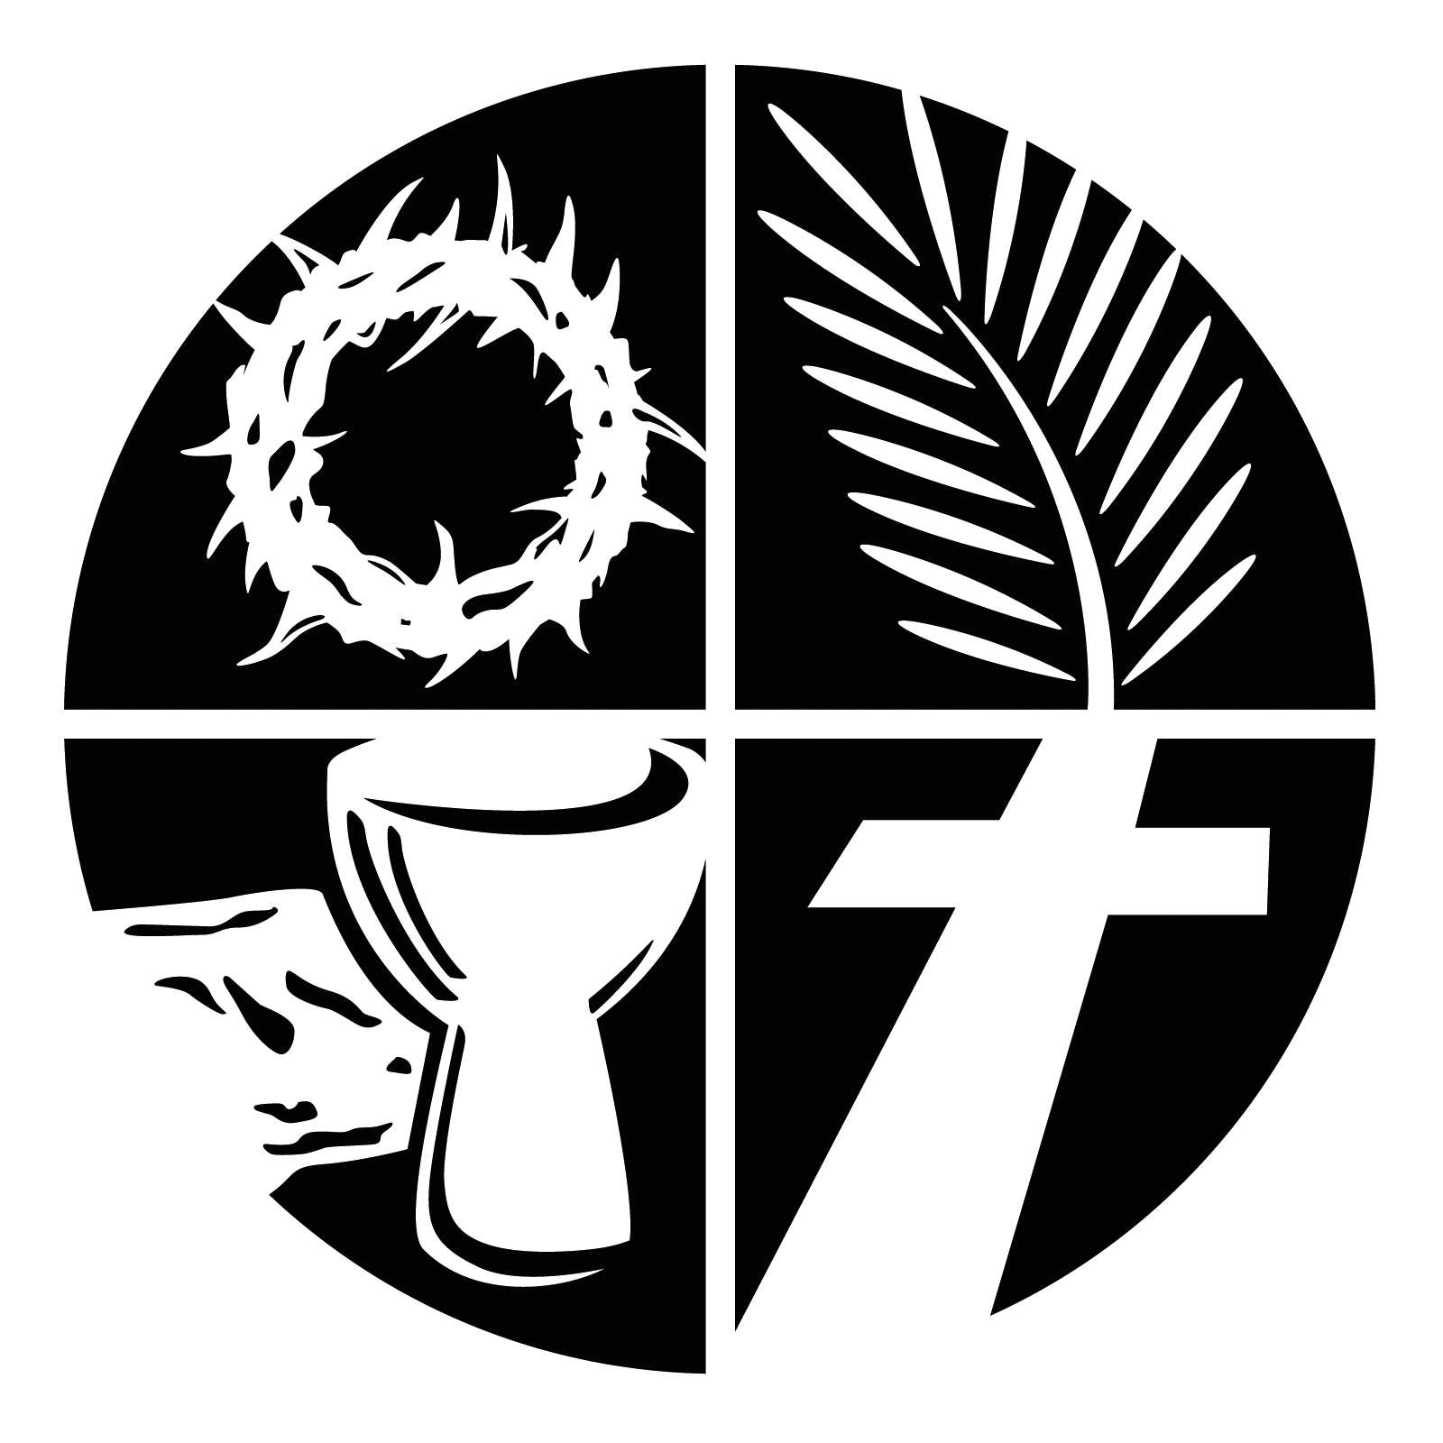

Welcome & Greeting

In the name of the Father, and of the Son, and of the Holy Spirit. Amen

The Lord our redeemer be with you:
The Lord bless you
Jesus is the Lamb of God:
who takes away the sins of the world. Amen

We confess our sins to God

Cast your burden upon the Lord
and he will sustain you.

Create in us clean hearts, O God:
and renew a right spirit within us.

Cast us not away from your presence:
and take not your Holy Spirit from us.

Give us the joy of your saving help again:
and sustain us with your life-giving Spirit.
Lord God,
we have sinned against you;
we have done evil in your sight.
We are sorry and repent.
Have mercy on us according to your love.
Wash away our wrongdoing and
cleanse us from our sin.
Renew a right spirit within us
and restore us to the joy of your salvation,
through Jesus Christ our Lord. Amen.

Kyrie eleison (said):
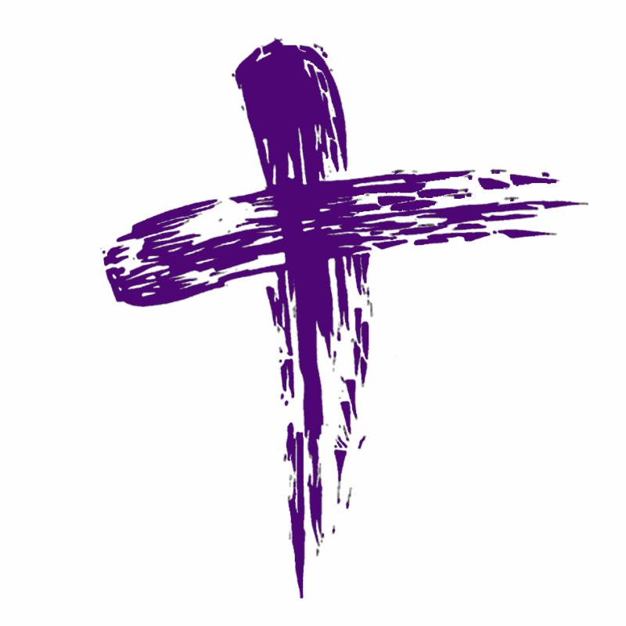

Lord have mercy.
Lord have mercy.

Christ have mercy.
Christ have mercy.

Lord have mercy.
Lord have mercy.

The leader declares God’s forgiveness

The Collect is said.

Our Readings

A reading from the Old or New Testament

After the Bible reading :

This is the word of the Lord.
Thanks be to God.

The Gospel

After a Gospel reading:
This is the Gospel of the Lord.
Praise to you, O Christ.

Sermon

Profession of Faith

We believe

Though he was divine,
he did not cling to equality with God,
but made himself nothing.
Taking the form of a slave,
he was born in human likeness.
He humbled himself,
and was obedient to death
even death on a cross.
Therefore God has raised him on high,
and given him the name above every name:
that at the name of Jesus
every knee should bow,
and every voice proclaim
that Jesus Christ is Lord
to the glory of God the Father. Amen.
(From Philippians 2)

Our Intercessions

We pray for the Church and for the world. At the end we say:

Merciful Father,
Accept these prayers for the sake of your Son, our Saviour Jesus Christ. Amen
We share Christ’s Peace

The peace of the Lord be always with you
And also with you.

The Eucharist

The Lord be with you:
and also with you.
Lift up your hearts.
We lift them to the Lord.
Let us give thanks to the Lord our God.
It is right to give him thanks and praise.

It is right to praise you, Father, Lord of all creation;
in your love you made us for yourself.
When we turned away you did not reject us,
but came to meet us in your Son.
You embraced us as your children
and welcomed us to sit and eat with you.

In Christ you shared our life
that we might live in him and he in us.
He opened his arms of love upon the cross
and made for all the perfect sacrifice for sin.

The Priest continues.

On the night he was betrayed,
at supper with his friends
he took bread, and gave you thanks;
he broke it and gave it to them, saying:
Take, eat; this is my body which is given for you;
do this in remembrance of me.
Father, we do this in remembrance of him:
his body is the bread of life.

At the end of supper, taking the cup of wine,
he gave you thanks, and said:
Drink this, all of you; this is my blood of the new
covenant, which is shed for you for the forgiveness of sins; do this in remembrance of me.
Father, we do this in remembrance of him:
his blood is shed for all.

As we proclaim his death and celebrate his rising in glory, send your Holy Spirit that this bread and this wine may be to us the body and the blood of your dear Son.
As we eat and drink these holy gifts make us one in Christ, our risen Lord.

With your whole Church throughout the world
we offer you this sacrifice of praise and lift our voice to join the eternal song of heaven:

Holy, holy, holy Lord,
God of power and might,
Heaven and earth are full of your glory.
Hosanna in the highest.
Blessed is he who comes in the name of the Lord.
Hosanna in the highest.

The Lord’s Prayer

Jesus taught us to call God our Father, so we have
courage to say:

Our Father in heaven,
hallowed be your name,
your kingdom come,
your will be done,
on earth as in heaven.
Give us today our daily bread.
Forgive us our sins
as we forgive those who sin against us.
Lead us not into temptation
but deliver us from evil.
For the kingdom, the power, and the glory are yours
now and for ever. Amen.

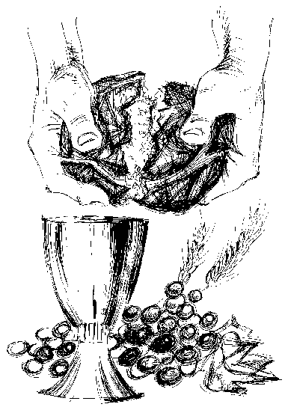

Breaking of Bread

We break this bread to share in the body of Christ.

Though we are many, we are one body, because we all share in one bread.

Giving of Communion

God’s holy gifts for God’s holy people:
Jesus Christ is holy,
Jesus Christ is Lord,
to the Glory of God the Father.

We do not presume to come to this table, merciful Lord,
trusting in our own righteousness,
but in your manifold and great mercies.
We are not worthy
so much as to gather up the crumbs under your table.
But you are the same Lord,
whose nature is always to have mercy.
Grant us therefore, gracious Lord,
so to eat the flesh of your dear Son Jesus Christ
and to drink his blood,
that our sinful bodies may be made clean by his body
and our souls washed through his most precious blood,
and that we may evermore dwell in him, and he in us.

A post communion prayer is said by the priest and we pray together:

Merciful God, you have called us to your table and fed us with the bread of life.
Draw us and all people to your Son, our Saviour Jesus Christ. Amen.

Blessing

May God the Father, who does not despise the broken spirit, give to you a contrite heart. Amen.

May Christ, who bore our sins in his body on the tree, heal you by his wounds. Amen.

May the Holy Spirit, who leads us into all truth, speak to you words of pardon and peace. Amen.

And the blessing of God Almighty, the Father Son and the Holy Spirit, be among you and remain with you always. Amen.

Go in peace to love and serve the Lord.
In the name of Christ. Amen.

Common Worship: Services and Prayers for the Church of England, material from which is included in the service, is copyright ©The Archbishops' Council 2000.

