Easter Day
at St Cuthbert’s
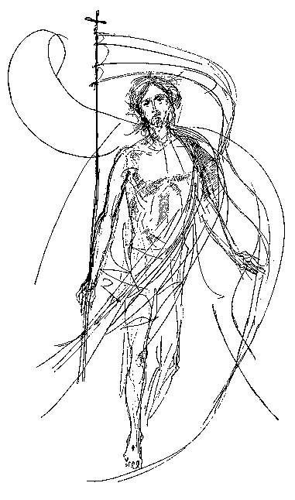

The Lord be with you
And also with you

Invitation to Confession

Christ our Passover lamb has been sacrificed for us. Let us therefore rejoice by putting away all malice and evil and confessing our sins with a sincere and true heart.

May the God of love and power forgive you and free you from your sins, heal and strengthen you by his Spirit, and raise you to new life in Christ our Lord. Amen

Readings and short talk

Acts 10: 34-43

Mark 16: 1-8

Prayers followed by the Peace

The peace
The risen Christ came and stood among his disciples and said, ‘Peace be with you.’ Then were they glad when they saw the Lord. Alleluia.

The peace of the Lord be always with you
And also with you.

The Eucharistic Prayer

The Lord is here.
His Spirit is with us.

Lift up your hearts.
We lift them to the Lord.

Let us give thanks to the Lord our God.
It is right to give thanks and praise.

Father, we give you thanks and praise through your beloved Son Jesus Christ, your living Word, through whom you have created all things; who was sent by you in your great goodness to be our Saviour.
But chiefly are we bound to praise you because you raised him gloriously from the dead. For he is the true paschal lamb who was offered for us, and has taken away the sin of the world. By his death he has destroyed death, and by his rising to life again he has restored to us everlasting life.

Therefore, with angels and archangels, and with all the company of heaven, we proclaim your great and glorious name, for ever praising you and saying:

Holy, holy, holy Lord, God of power and might, heaven and earth are full of your glory. Hosanna in the highest. Blessed is he who comes in the name of the Lord. Hosanna in the highest.

Lord, you are holy indeed, the source of all holiness; grant that
by the power of your Holy Spirit, and according to your holy will, these gifts of bread and wine may be to us the body and blood of our Lord Jesus Christ; who, in the same night that he was betrayed, took bread and gave you thanks; he broke it and gave it to his disciples, saying, Take, eat; this is my body which is given for you; do this in remembrance of me.

In the same way, after supper he took the cup and gave you thanks; he gave it to them, saying: Drink this, all of you; this is my blood of the new covenant, which is shed for you and for many for the forgiveness of sins. Do this, as often as you drink it, in remembrance of me.

Christ is the bread of life:

When we eat this bread and drink this cup, we proclaim your death, Lord Jesus, until you come in glory.

And so, Father, calling to mind his death on the cross, his perfect sacrifice made once for the sins of the whole world; rejoicing in his mighty resurrection and glorious ascension, and looking for his coming in glory, we celebrate this memorial of our redemption. As we offer you this our sacrifice of praise and thanksgiving, we bring before you this bread and this cup and we thank you for counting us worthy to stand in your presence and serve you.

Send the Holy Spirit on your people and gather into one in your kingdom all who share this one bread and one cup, so that we, in the company of all the saints, may praise and glorify you for ever, through Jesus Christ our Lord; by whom, and with whom and in whom, in the unity of the Holy Spirit, all honour and glory be yours, almighty Father, for ever and ever. Amen

All:
Our Father in heaven,
hallowed be your name,
your kingdom come,
Your will be done,
on earth as in heaven.
Give us today our daily bread.
Forgive us our sins as we forgive those who sin against us.
Lead us not into temptation but deliver us from evil.
For the kingdom, the power, and the glory are yours now and forever. Amen.

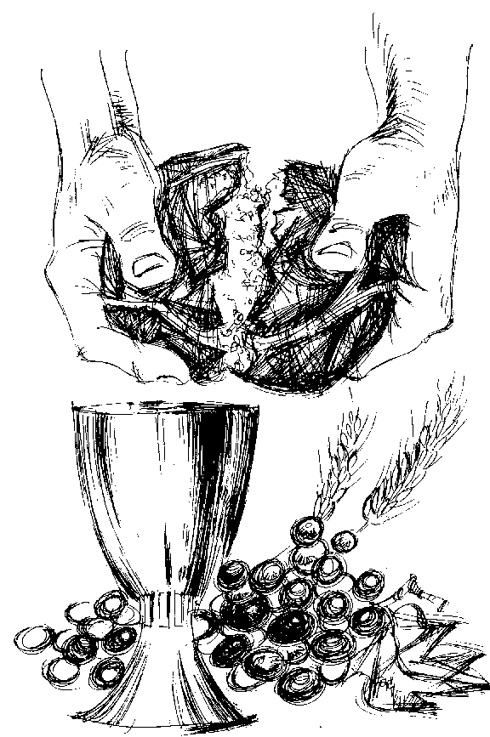

Breaking of the Bread

We break this bread
to share in the body of Christ.
Though we are many, we are one body, because we all share in one bread.

Communion

Jesus is the Lamb of God who takes away the sin of the world. Blessed are those who are called to his supper.

All:
Lord, I am not worthy
to receive you,
but only say the word, and I shall be healed.

Prayer after Communion

Father of all,
we give you thanks and praise,
that when we were still far off you met us in your Son and brought us home. Dying and living,
he declared your love, gave us grace, and opened the gate of glory.

All:
May we who share
Christ’s body
live his risen life;
we who drink his cup
bring life to others;
we whom the Spirit
lights give light to
the world. Keep us firm
in the hope
you have set before us,
so we and all
your children shall be
free, and the
whole earth live to
praise your name;
through Christ our Lord.
Amen.

THE BLESSING

The God of peace, who brought again from the dead our Lord Jesus, that great shepherd of the sheep, through the blood of the eternal covenant, make you perfect in every good work to do his will, working in you that which is well-pleasing in his sight; and the blessing of God almighty, the Father, the Son, and the Holy Spirit, be among you and remain with you always.
All: Amen.

Go in peace to love and serve the Lord.
All:
In the name of Christ. Amen.

