Financial Statements

of the

Parochial Church Council of St Cuthbert North Wembley

For the year ending 31st December 2020

Vicar: Treasurer:
The Reverend Steve Morris Christine Morris
Book keeping and
Management Accounts
The Vicarage Harry and Valerie Harrigan
214 Carlton Avenue West
North Wembley
Middx
HA0 3QY

Bankers Independent Examiner
Barclays Bank PLC Rev. David Green, FCA
Kensington & Chelsea Group Gowers Ltd
PO Box 4599 The Old School House,
London SW3 1XE Bridge Road, Hunton Bridge
Kings Langley, Herts
WD4 8SZ

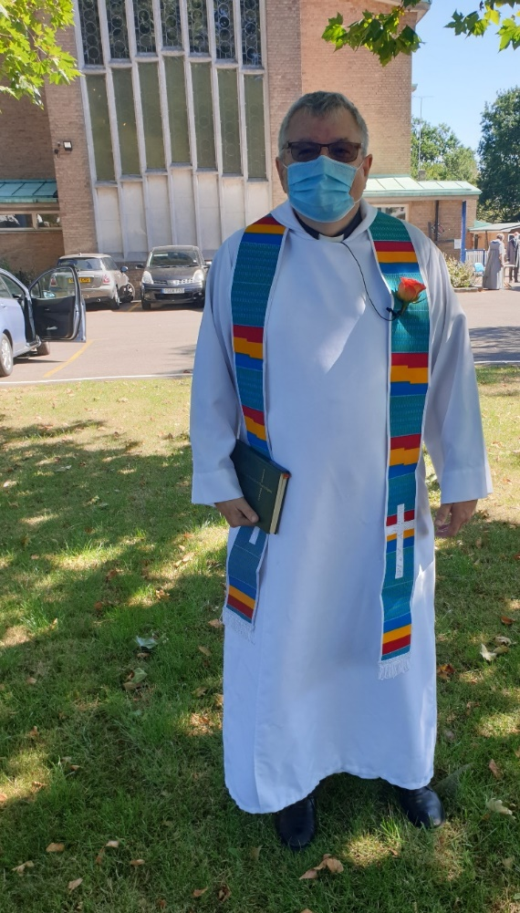

St Cuthbert’s PCC has the responsibility of cooperating with the incumbent, the Reverend Steven Morris, in promoting the ecclesiastical parish and the whole mission of the Church.
The PCC is committed to our church growing and being a beacon of hope in this parish.
Vicar’s report – 2020, a year like no other
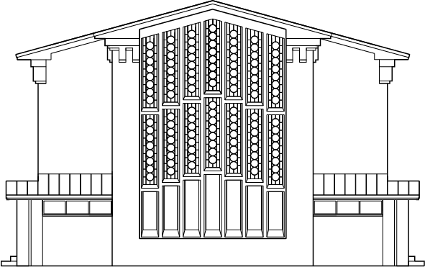
This year
We have just lived through a year that is like no other that we have ever experienced as individuals and as a church. None of us could have imagined that this was about to be upon us. At the beginning of the year, life was going on pretty much as normal. We were running Memory Cafe, working on services and doing all the normal things that a parish church does. We were settled and ready for what life threw at us, or at least we thought we were.
We began to hear unsettling stories about the Covid virus. They were particularly worrying as the virus seemed to be most serious for elders and some of our most obvious ministry was to that group. I am very glad that we decided to stop Memory Cafe a week before we were actually had to. I sometimes wonder if we saved some lives by doing this. I think that we did.
What followed has been pretty much a year when we have had to abandon our normal lives and normal church practices. For many months the church itself has been closed and when we have opened, we have not been able to run things as normal. It would be easy to feel despairing about this and we do feel a great deal of grief for all the many people who have died from this terrible illness. Being so close to Northwick Park Hospital we are so aware of the ravages of this disease.
However, as we take stock there are many things that have happened this year and that we now do differently as a result of Covid and we need to be grateful, I think, for some of these.
As far as services go, we have managed to move online. At the start of this pandemic I was a committed technophobe but I have learned so many new things with the help of my daughter, Emily. We have provided services as an audio and with Trevor and his family's help as videos, saved onto YouTube. It has been enjoyable doing these and I think we will need to continue doing this in some fashion when life is back to normal. Joan has run an amazing Sunday School online and I think this is a very interesting initiative. We have also stayed closely in touch with Daniel’s Den and toddlers group and we look forward to developments in this area. Plus, we have a thriving prayer group on WhatsApp. We now do our services live-streamed on Zoom and it is heartening to see so many attending.
During the lockdown, we have also carried out significant building work on our Hall and repaired the church roof. These are huge jobs and when we can get back to normal will bear much fruit for this parish. Trevor Goddard, who is now our Assistant Priest here, managed the project with real skill and I am personally extremely grateful to him. The Hall is transformed and will become a community hub and this is all thanks to Brent Council and the grant we received.
As well as the building works we have continued our pastoral emphasis. Since lockdown, I have kept up a steady schedule of phone calls with people and tried to make sure that no-one is too lonely. I have also instigated a series of Zoom coffee and prayer sessions so we keep in touch with people. As a church, we have a heart for those in need and I am inspired very much by your example. I especially liked the idea of sending hampers to those on their own at Christmas. This was made possible by a generous donation from a congregation member and also by the creativity of Tina who put the hampers together.
Our PCC has become adept at using Zoom and this has helped us to continue with the management and leadership of this church .
Perhaps the greatest innovation has been the way we have taken Memory Cafe out of the church and into people’s homes. The initiative was entirely conceived by Emily and she has run it with tremendous skill and dedication, and there's a section on what we have done a little bit later in this report. We also managed to get some grants to help support this but we will need to do more fund raising early in the new year.
I was made interim vicar at St Laurence Cowley. I carried out this role alongside my role here at st Cuthbert’s.
We're not out of the woods at all. Covid has resulted in a huge financial hit for this church and we need to ask you to be as generous as you can in your tithes and offerings. But my feeling is that we will come through this stronger than ever and our church family here will be stronger than ever.
And our vision
We face the prospect of a very different kind of church but with still the same kinds of pressures and issues that are out there in the world. Since I have been here, the focus has been on blessing our community and showing the love of God for all people and this vision, I think, will still stand us in good stead. We still stick with the idea that we need to help people to come in, focus on God, and then go out and be a blessing in the community but I'm sure we will find new things and new ways as we go forward.
We are looking to really be a church at the heart of our community – to help the community thrive and for us to be a place of love and joy.
Steve
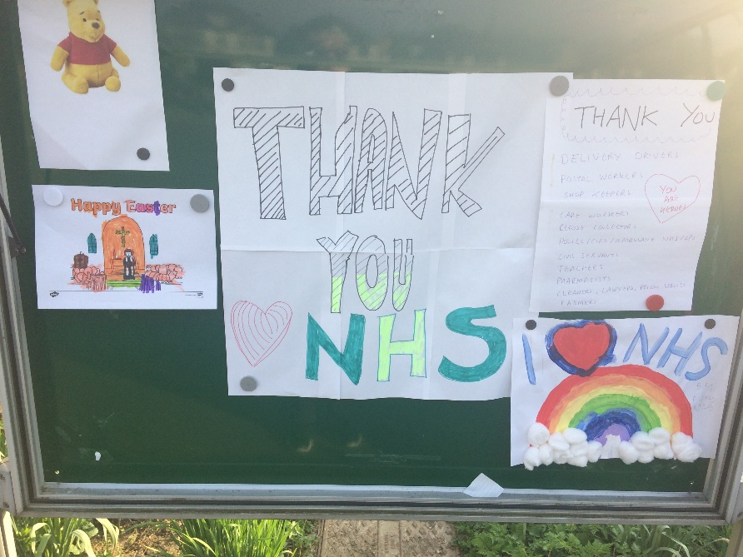

St Cuthbert church associate vicar Trevor Goddard review 2020
Steve Morris and I have become good friends over the last few years, and it was in March 2020 that we each became Associate Vicars of each other’s parishes. On the 1st of March 2020, Bishop Pete came and licenced Steve and I at a lovely café style service in St Cuthbert’s church, which was well attended by members of the congregation of both churches. Who would have thought that within a few weeks both of our churches would be closed because of the corona virus pandemic.
Both Steve and I work really well together, having complimentary gifts and therefore we are able to encourage and support each other. It's also been good to have a colleague to reflect on one’s own ministry with, to have someone to pray with and to be supported in prayer by. Being a church is about the coming together of a group of people to share God’s message of love and St Cuthbert’s has been amazing at doing this over many years and reaching out to its community in practical ways. The Memory Café is a huge encouragement, not only to the St Cuthbert’s community, but also to the wider church community as its message and model have spread widely. In my own parish, we have a very successful Memory Café that is run by the local library group. Under lockdown, as the Memory Cafe has not been able to meet, the development of Memory Cafe at Home has been a very important development. It has been an amazing success in supporting so many people who are isolated and alone. This is thanks to the creativity, hard work and dedication of Emily Morris who leads this new project.
Over the past year I have project-managed the programme to update the church hall facilities. The plans we drew up for the hall were to improve disabled access and make it more environmentally friendly by improving the insulation, double glazing the windows, and updating the heating system and lighting. We updated all the facilities these including a new kitchen area, improved storage, new toilets, including a new disabled toilet, and a baby changing area. Our aim was to be able to accommodate more community group use and therefore improve facilities for the whole area. The new layout and updated facilities have been very well received from all of the groups that are currently using the hall. We look forward to the hall being a greater centre for community activities and for the church as we eventually move out of lockdown in 2021. The new refurbished hall should also see improved revenue to support the mission of the church community in the future.
I look forward, in partnership with Steve, to continue to explore new ways to guide and support the community of St Cuthbert’s Church during 2021. You are continually in my prayers.
Rev Trevor Goddard

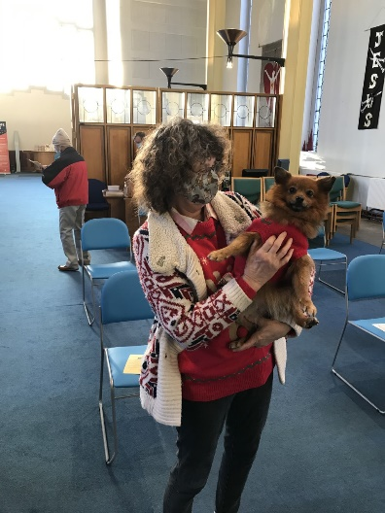
Warden’s report

What a difficult year this has been for all of us, not least at St Cuthbert’s.

As soon as the Pandemic took hold the government declared a lockdown from 23 March and St Cuthbert’s were forced to change its services by making social distancing and face coverings imperative; thus we had a complete rearrangement in the spacing of the chairs and a halt to anything other than the one service on Sundays with our vicar, Steve, conducting it all himself, no readers, no hymns; only piped music, and a little light music played by our precious Anna at the beginning and end of our services to lift us and a much reduced congregation to fit in with the socially distanced chairs at 2m apart!

In addition, our nursery had to close its doors, church hire bookings plummeted, and Daniels Den also closed and the staff prepared to move everything for the renovation work to take place for the first phase of this work.

The first phase of the work was completed just in time for the nursery to reopen in September. However, with all this work having taken place during lockdown and the summer months’ reprieve, we have not finished and are looking at two further stages of work, the roof itself which requires necessary replacement in part, due to flooding. This has not been practical at this time of year as a scaffold would be required to protect the building and the autumn weather has not been kind enough to allow this so it has been postponed until further notice. While the second phase of converting the old toilet block into offices has also been put on hold until sufficient funding is made available.

With the summer reprieve after lockdown, church services continued but then we were hit in October/November with tier 3 and tier 4 closures which then put our services at risk and we subsequently went on line and Steve commenced videoed/recorded services which could be accessed from the website, with Zoom sessions for our PCC meetings. Memory Café at Home continued - what a success this has been and for those who could not link up with technology, a package containing stories, poems, written quiz and news was posted to these persons. Well done to Emily (also to Megan who videoed her seated exercises from Memory Cafe) and others who helped with the technology including Trevor Goddard’s son.

This year in July the funeral of our dear Deborah Currens took place; a former lay reader of St Cuthberts who served us well over the years and who lost her long battle with cancer. Due to Covid 19 restrictions we were only allowed up to 30 mourners in the church. Our condolences to the Eddie, Chloe and Fraser.

Following this, one of our parishioners, Maggie Johnson, also died recently and her funeral took place on 21 December. Once again because of Covid restrictions only 30 persons were allowed to attend in church but there was a beautiful funeral cortege bearing the coffin of dear Maggie and drawn by two white horses. Our condolences go out to Errol, the children and all the family.

The Christmas Carol Service took place on Saturday 19 December which was attended by readers, clergy and Elvis as worship leader with a few members of the congregation. No singing by the congregation, only Elvis from the front, but this was truly wonderful as he did it in his usual calypso style supported by Lionel on bongos. Thank you both for making it special. The service was recorded and was put on the website. It was decided that other Christmas services should be videoed in accordance with safety procedures.

I wish to take this opportunity to thank all those who have managed to keep St Cuthbert’s together over this year and for all their hard work. Special thanks go to Steve and Christine, who are always one step ahead and always prepared to go the extra mile for us, as is Trevor and Jacqui, his wife. Thanks too to those in the background without whom we would be struggling: Tina, our Office Administrator, Harry our Bookkeeper, Rev Green our Auditor and Cathy our Housekeeper who continues to keep our church and hall in order. Avril, Paul and Lionel and our PCC plus Joan and Patrick, thanks to each of you, our unsung heroes. Thanks and best wishes to all our parish and we pray for a safe journey into this New Year with renewed energy and blessings for all.
A delayed socially distanced Annual Parochial Church Meeting took place in church on 20 September 2020 following the Sunday Service. At this meeting various reports on the church building and the hall were read and accepted. It was noted that the church and hall were currently in good order. There were 107 on the electoral roll this year. The two churchwardens, Lionel Abbey and Lynn Dube, were sworn in for one year in the current Covid crisis and the Pcc were also sworn in for two years with the understanding that they could withdraw at any time.
The vicar held an Advent course in December via zoom, one daytime and one evening in weekly sessions. He based the course on his latest Advent book, “Frontline Advent” which also incorporated reflections by Barry Hingston. Members of St Cuthberts, the Annunciation church and the parish church in Cowley, Uxbridge were invited to join.

Lynn Dubé

Memory Café at Home

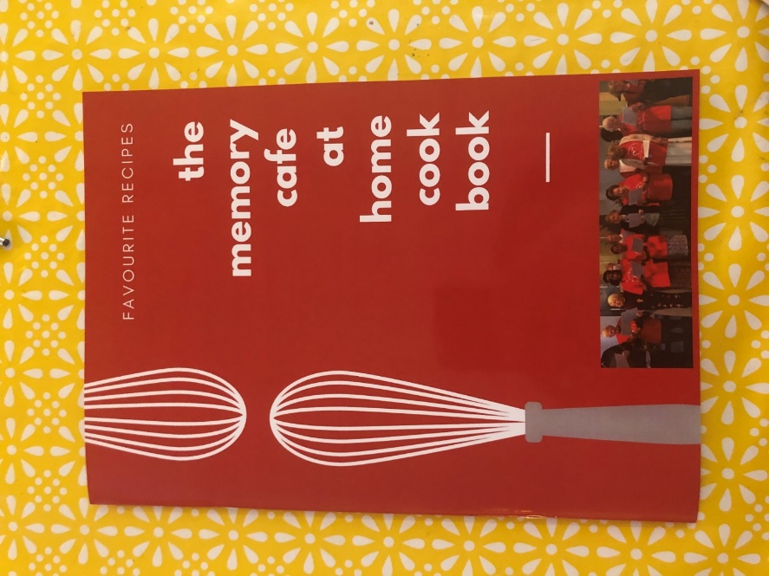
This year, at the end of June, we set up the Memory Café at Home in response to Covid 19. Previously, we had had up to 100 elderly people walking through our doors each week to sing, exercise and chat. The Memory Café at Home project has several different strands and we currently have over 70 people involved. We offer connection through the post, phone and internet and have had several events throughout the year as well.

Our first strand is offering connection via the phone. This year we have made hundreds of calls, keeping in contact with people who may be lonely and lack of access to technology. We have sent out 420 individual entertainment packs to people across the country containing stories, quizzes, poems and gifts. These gifts have included our Christmas gift which was a hand-designed recipe book with members’ favorite recipes that they sent in throughout the year. We also have sent out 4 radio CDs throughout the year coming to a total of 141 individual CDs sent.

Our final form of the project has been through the internet. Each week we have run a quiz (23 quizzes this year!) as well as other events. These events have included having a Scam and Fraud Awareness event run by NatWest Bank as well as a Christmas Cabaret Show that involved young performing talent from across the country. This was shown to 32 Memory Café goers as well as to the general public to 210 families. We raised over £700 in this second showing towards the continuation of Memory Café at Home next year.

We have also provided resources for 16 similar groups across the country to view online. I hope in the coming year to increase our collaboration with other groups running similar projects.

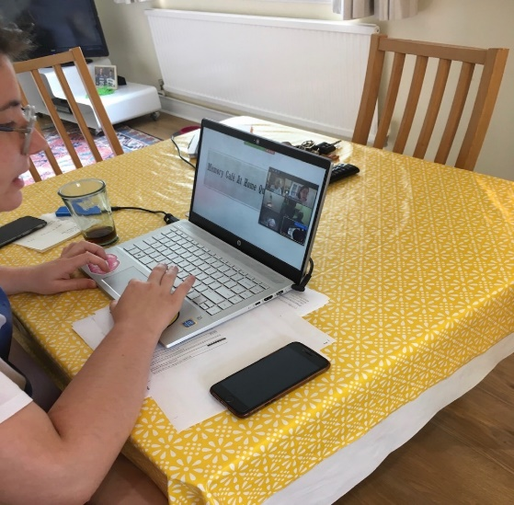
It has been wonderful to form connections with all of the wonderful Memory Café folks. It has been a really difficult year for them, and I hope in the next year we can move towards returning in person. Until then, we plan to continue to run Memory Café at Home. A massive thank you to the Memory Café at Home team: Steve, Trevor, Tina and all the support I have received from the Church, PCC and contributors towards the events, CDs and packs.

From Emily Morris
Memory Cafe at Home Project Coordinator

Health and safety

We have taken great care to follow the guidelines in these Covid times. We closed Memory Café a week before we officially had to. When we have been able to run services we have made sure that: everyone signs in and gels their hands, that they wear a mask at all times and remain seated, that they follow our one-way system to avoid social contacts and that they gel their hands again before receiving Communion in one kind.
We continue to review our risk assessments to keep everyone safe and we follow all government guidelines.
Lionel Abbey
Church Warden

Safeguarding
The PCC at St. Cuthbert's takes the safety of all those who use the site very seriously and 'Safeguarding' is an agenda item at every PCC meeting.
Joan Alleyne continues her much appreciated work with children on a Sunday and is our Children's Champion. Liz Brookwick is our Elder's Champion.
All members of the PCC have received training in Safeguarding. This is either using the diocesan on-line training or a full day at Diocesan House. Safeguarding at St. Cuthbert's is reviewed annually using The Diocese of London Parish self-audit and the results are acted upon.
Hazel Bathurst
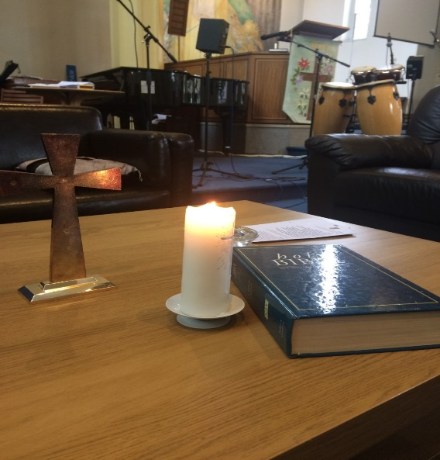
Deanery Synod Report 2019 and Electoral Roll
Brent Deanery Synod, now known as Anglicans in Brent, is made up of the clergy and elected representatives of the people of each of the churches in Brent. The number of representatives from each parish depends upon the number of people on the electoral roll.
We have two representatives now.
There are up to three meetings each year which, after a short business meeting, focuses on a wide variety of topics affecting the church in Brent and beyond. Most of the meetings are open to all.
The meetings are taking place via Zoom during the pandemic.
Christine Morris

Electoral Roll
We have 107 people on our electoral roll.

Kidz Church
Joan has set up and run a Sunday school at home by Zoom which is a tremendous innovation.

Ploughman’s
With the restrictions on meetings this year, we only managed to hold two lunches - in February and March. Both were well attended, with an average of 14, and we were pleased that our numbers had risen. The themes were Lemons and Daffodils and then Tulips, and we enjoyed the usual fare of rolls, butter and cheese, with pickles and a little salad, and coffee cake and tea or coffee to follow.

I was grateful to my helpers, Ruth and David, and I appreciated the way everyone assisted with clearing away afterwards. I know that we all miss these gatherings where we have a good time eating, chatting and laughing, and I hope that it will not be too long before we can meet again.

Valerie Waterman

Financial report
The year under review has been clearly affected by the Covid19 virus. In the circumstances we have a reasonable financial position at the year end and continue to have a positive bank balance.
As previously, our buildings were our main focus for improvement, with the upgrade of church hall due for completion early in the New Year. Although the costs overran we have increased the transfer to the sinking fund from £5,000 to £10,000 to maintain a positive fund balance for future projects. We are very grateful Trevor Goddard for Project Management and to Brent Council for the financing of this project.
Brent Council are also financing our Roofing Project which will be undertaken in 2021.Their grant of £13,600 is carried forward to offset the cost and is included in Creditors.
The income this year, excluding grants, was much lower due to the hall upgrade reducing lettings income together with Covid19 impacting church availability. The suspension of the Memory Café early the year was compensated by Memory Café at Home (MCAH) and we are grateful for the financing of this new initiative. We also transferred £3,000 from the Vision Fund Reserve to support the set-up of MCAH.
Our profit and loss account shows a deficit of £49,348 for the year after the sinking fund transfer and we have a bank balance of £112,055 including the £13,600 from Brent Council for the roof as above.
What is next on the horizon?
We have continued to improve the fabric of the church over the past few years however this is ongoing and we will explore further plans to develop the church so that we can improve our outreach work with the community. We will continue to invest at least £5,000 annually in our sinking fund to help us budget for other planned and cyclical works.
Our ambition as a church is to be a blessing to our community, and this does take a level of financial commitment. We will continue to support our social outreach activities.
As a church family, we have been faithful with our financial support, and we need to continue to do so.
Christine Morris

Reserves policy
As a PCC, we have not previously had a reserves policy. We have considered the need to start a reserves policy, and agreed that we will hold our reserves in the deposit account. This is to provide primarily for the capital liabilities to come with the electrics (see below). Our first priority is to reach our target of £60,000. We will keep this reserves total under review with the PCC and develop a more detailed policy as we move forward. It may be as the amount accumulates that we can find a place with a greater return, and we will take advice on this. However, at the moment, there are no reserves to manage.

Special thanks
To those who have helped us to keep our accounts in order, and produce these figures.

Structure, governance and management
The methods of appointment of PCC members is set out in the Church Representation Rules. At St Cuthberts, the membership of the PCC consists of the incumbent, churchwardens, and members elected by the members of the congregation who are on the electoral roll of the church.

The PCC members are responsible for making decisions on all matters of general concern and importance to the parish including on deciding how the funds of the PCC are to be spent.

The PCC met six times during the year with an average attendance of 75%. We have no sub committees.

Administrative information

St Cuthberts Church is at 214 Carlton Avenue West, North Wembley, Middlesex, HA0 3QY. It is part of the Diocese of London, in the Willesden area. The PCC is a body corporate (PCC Powers Measures 1956, Church Representation Rules 2006) and a charity currently excepted from registration with the Charity Commission.

PCC members who have served at any time from 1st January 2020 until the date this report was approved are:

Names of the PCC members
Ex Officio members
The Reverend Steve Morris
The Reverend Trevor Goddard
Lynn Dube (churchwarden)
Lionel Abbey (churchwarden)

Elected members
Hazel Bathurst (representative on the Deanery Synod)
Avril Nickolson
Patrick Alleyne
David Loder
Neil Brookwick
Michael Bruce
Christine Lawton
Jennifer Lee
Slim Lim
Christine Morris (treasurer)

Approved by the Parochial Church Council on
and signed on its behalf by

Rev Steve Morris.

Independent Examiner’s Report to the Parochial Church Council
of St Cuthbert’s, North Wembley

I report on the accounts of the PCC for the year ended 31st December 2020, which are set out on pages 16 to 22.

Respective responsibilities of trustees and examiner

As members of the PCC, you are responsible for the preparation of the accounts. You consider that an audit is not required for this year under Regulation 3(3) of the Church Accounting Regulations 1997 to 2001 (the Regulations) and section 144(2) of the Charities Act 2011 (the 2011 Act).
Having satisfied myself that the charity is not subject to audit and is eligible for independent examination, it is my responsibility to:

- Examine the accounts under section 145 of the 2011 Act and Regulation 3(3);
- To follow the procedures laid down in the general Directions given by the Charity Commission under section 145(5)(b) of the 2011 Act; and
- To state whether particular matters have come to my attention.

Basis of independent examiner's report

My examination was carried out in accordance with the General Directions given by the Charity Commission and guidelines from the Finance Division of the Archbishop’s Council. An examination includes a review of the accounting records kept by the PCC and a comparison of the accounts presented with those records. It also includes consideration of any unusual items or disclosures in the accounts, and seeking explanations from you as trustees concerning any such matters. The procedures undertaken do not provide all the evidence that would be required in an audit and consequently no opinion is given as to whether the accounts present a 'true and fair view' and the report is limited to those matters set out in the statement below.

Independent examiner's statement

In connection with my examination, no matter has come to my attention:

1) Which gives me reasonable cause to believe that in any material respect the requirements to:

- Keep accounting records in accordance with section 130 of the 2011 Act; and
- To prepare accounts which accord with the accounting records, comply with the accounting requirements of the 2011 Act, the Regulations and with the methods and principles of the Statement of Recommended Practice: Accounting and Reporting by Charities have not been met; or

2) To which, in my opinion, attention should be drawn in order to enable a proper understanding of the accounts to be reached.

Rev. David M Green FCA
Gowers Limited,
Chartered Accountants.
The Old School House,
Bridge Road,
Hunton Bridge,
Kings Langley,
Herts. WD4 8SZ

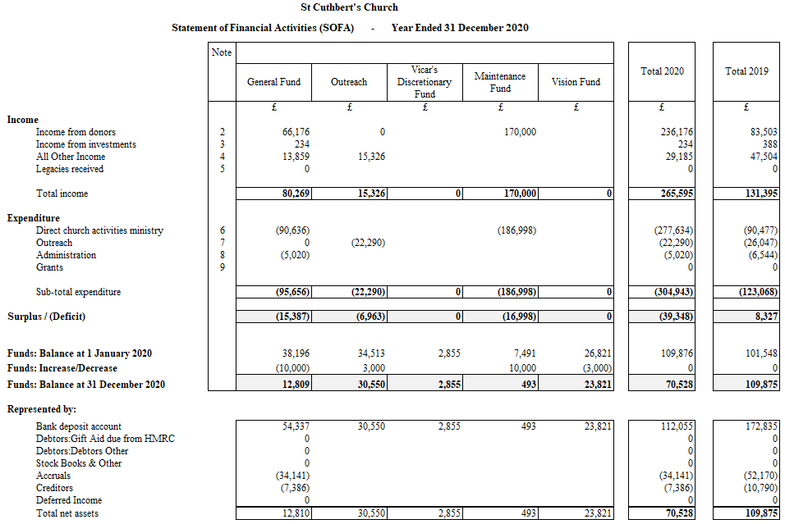

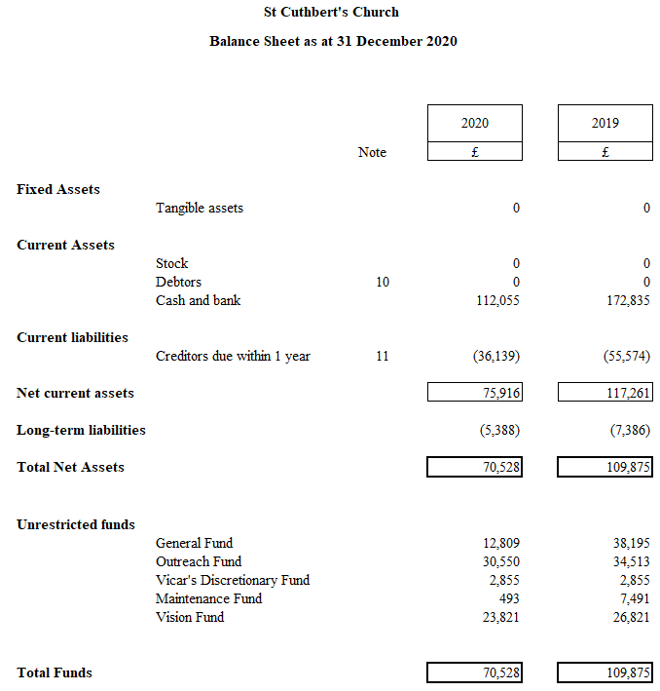

Approved by the Parochial Church Council on
and signed on its behalf by

Rev Steve Morris.

Parochial Church Council of St Cuthbert, North Wembley
Notes to the Financial Statements – year ended 31 December 2020

Accounting Policies
The financial statements of the PCC have been prepared in accordance with the Church Accounting Regulations 1997 as amended by the Church Accounting (Amendment) Regulations 2001 together with applicable accounting standards and the Charities SORP. The financial statements have been prepared under the historical cost convention.

Funds
General Fund represents the funds of the PCC that are not subject to any restrictions regarding their use and are available on the general purposes of the PCC. Funds designated for a particular purpose by the PCC are also unrestricted.

The accounts include transactions, assets and liabilities for which the PCC is responsible in law. They do not include the accounts of other church groups that owe an affiliation to another body, nor those that are informal gatherings of Church members.

Incoming Resources
Voluntary income and capital sources
- Collections are recognised when received by or on behalf of the PCC.
- Planned giving receivable under Gift Aid is recognised only when received.
- Income tax recoverable on Gift Aid donations is recognised when the income is recognised.
- Grants and legacies to the PCC are accounted for as soon as the PCC is notified of its legal entitlement, the amount due is quantifiable and its ultimate receipt by the PCC is reasonably certain.
- Funds raised at fund raising events are accounted for gross.
- Sales of books and magazines from the bookstall are accounted for gross.

Other Income
Rental income from the letting of church premises is recognised when the rental is due.

Income from Investments
Interest entitlements are accounted for as they accrue.

Gains and losses on investments
Realised gains and losses are recognised when investments are sold. Unrealised gains and losses are accounted for on revaluation of investments at 31 December.

Resources used – grants
Grants and donations are accounted for when paid over or when awarded if that award creates a binding obligation on the PCC
Parochial Church Council of St Cuthbert, North Wembley
Notes to the Financial Statements – year ended 31 December 2020

Resources Used – Activities directly relating to the work of the church
The diocesan parish share is accounted for when paid. Any parish share unpaid at 31st December is provided for in these accounts as an operational (though not legal) liability and is shown as a creditor in the balance sheet.

Fixed Assets
Consecrated property and moveable church furnishings:
Consecrated and beneficed property of any kind is excluded from the accounts by s10(2)(a) & ( c) of the Charities Act 2011.

Movable church furnishings held by the Vicar and Churchwardens are on special trust for the PCC and which require a faculty for disposal are accounted as inalienable property unless consecrated. They are listed in the church’s inventory which can be inspected (at any reasonable time). For inalienable property acquired prior to 2004 there is insufficient cost information available and therefore such assets are not valued in the accounts. Items acquired since 1 January 2004 have been capitalised and depreciated over their current anticipated economic life (initially 4 years) on a straight line basis.

All expenditure incurred on the year on consecrated or beneficed buildings, individual items under £1,500 or on the repair of moveable church furnishings acquired before 1st January 2005 are written off.

Other fixtures , fittings and office equipment
Equipment used within the church premises is depreciated on a straight line basis over 4 years. Individual items of equipment with a purchase price of £1,500 or less is written off when the asset is acquired.

Other Functional Assets
Land and buildings held on behalf of the PCC for its own purposes (with LDF acting as Custodian Trustee) is included at estimated market value.

Investments
Investments are valued at market value at 31st December.

Current Assets
Amounts owing to the PCC at 31st December in respect of fees, rents and other income are shown as debtors less provision for amounts that may prove uncollectible.

